Introduction to RDBMS
(MINI PROJECT)
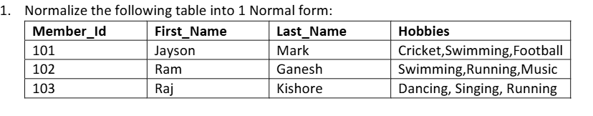
Member_id | First_Name | Last_Name | Hobby
101 | Jayson | Mark | Cricket
101 | jayson | Mark | Swimming
101 | Jayson | Mark | Football
102 | Ram | Ganesh | Swimming
102 | Ram | Ganesh | Running
102 | Ram | Ganesh | Music
103 | Raj | Kishore | Dancing
103 | Raj | Kishore | Singing
103 | Raj | kishore | running

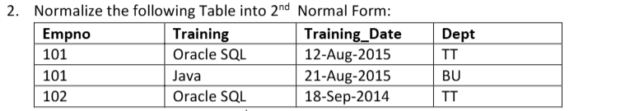
Employee table:-
Empno | Dept
101 | TT
102 | TT

Training table:-
Empno | training | Training_date
101 | Oracle sql | 12-aug-2015
101 | Java | 21-aug-2015
102 | Orackle sql | 18-sep-2014

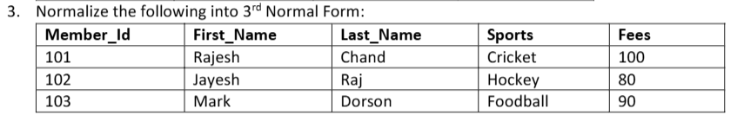

Member_id | First_Name | Last_Name
101 | Rajesh | Chand
102 | Jayesh | Raj
103 | Mark | Dorson

Member_id | Sports | Last_Name
101 | Cricket | 100
102 | Hockey | 80
103 | Football | 90

